**STORE SALES DATA: - REMOVED ALL BLANK ROWS, CHANGED COLUMN HEADER**

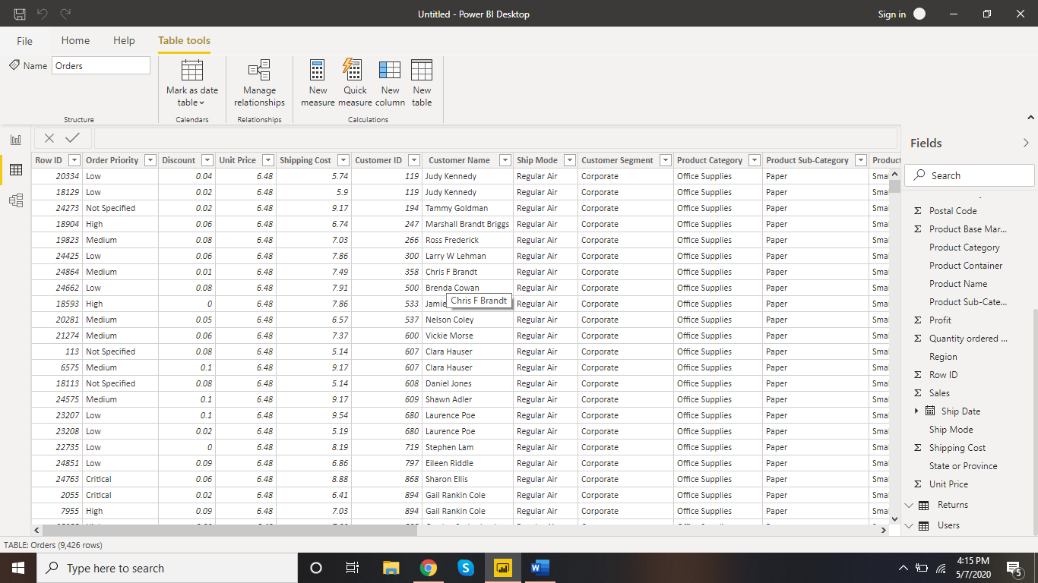

**NEW SALES TABLE USING APPEND QUERY:**

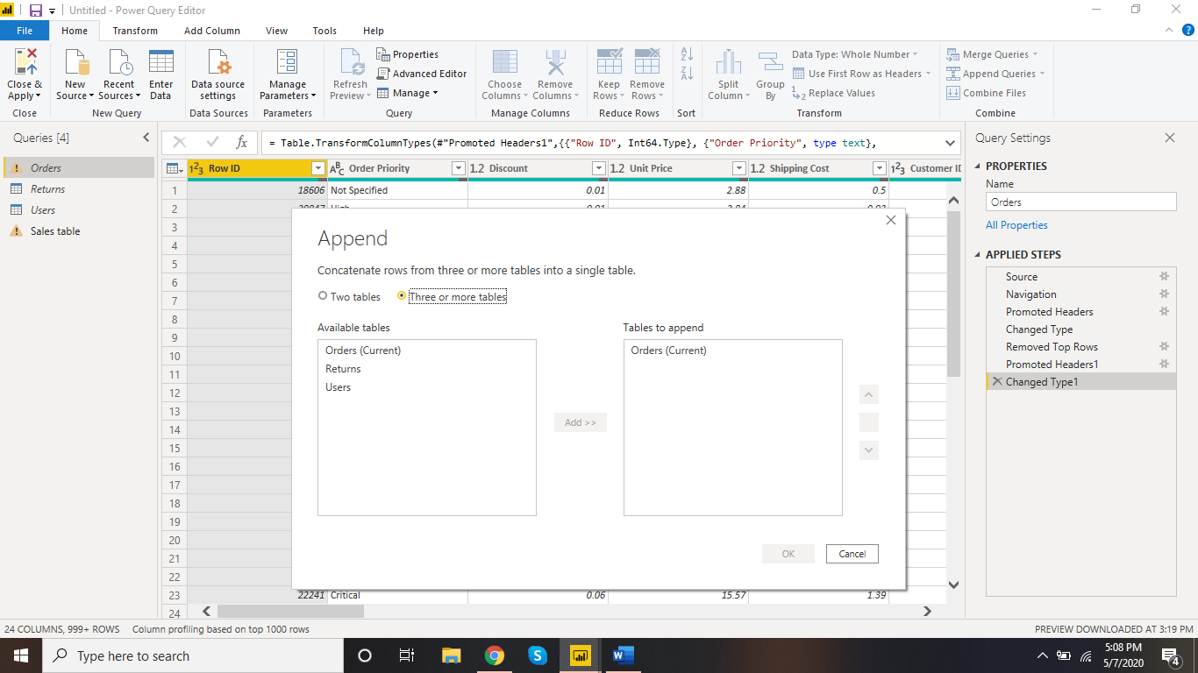

**DONUT CHART FOR SALES IN PRODUCT CATEGORY: WITH SLICER**

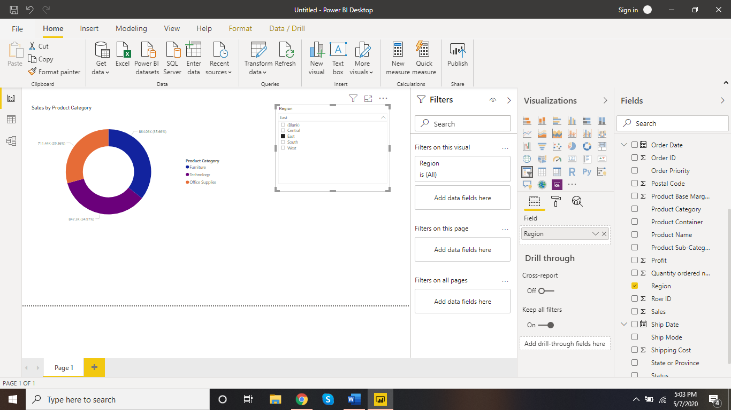

**LINE AND CLUSTERED COLUMN CHART:**

**CALIFORNIA HAS THE HIGHEST SALES IN TERMS OF TECHNOLOGY**

